**Monday May 6th, 2019**

19:32 — Another late start because of unrelated obligations earlier in the day.

19:39 — I’m going to try to follow a React weather building tutorial on YouTube to get the feel of building a basic React app from start to finish.

19:42 — By necessity, I just upgraded to the latest version of node on my Macbook.

19:45 — I’m waiting for react-create-app to install some different packages before I can configure my app.

19:53 — There are too many errors. I can’t even get the app to start.

19:58 — I used the command: *create-react-app weather-app* in terminal after seemingly having updated webpack. Hopefully this time I can get things to work.

20:05 — The error messages I’m facing are so long and obtuse I feel like this project is a complete waste of time.

20:06 — I guess I’ll go to the bathroom, take a short walk, and try the Scrimba course again.

20:44 — I just finished dinner. Let’s try to get some productive output out there before the day is over.

20:50 — Back to the .map ( ) business. The first time I tried using .map ( ) today I forgot that I needed to include a callback function lol.

21:01 — My current life mission is to debug these two errors:

Warning: React.createElement: type is invalid -- expected a string (for built-in components) or a class/function (for composite components) but got: array. Check the render method of `App`. in App

!

Invariant Violation: Element type is invalid: expected a string (for built-in components) or a class/function (for composite components) but got: object. (/node_modules/fbjs/lib/invariant.js:42)

They’ve been haunting me for like 3 days already lol.

21:04 — OMG! I’ve finally done it. I was getting close to the point of tears, but I discovered the problem. Previously in my App.js file I was using the following code:

function App() {

const ItemComponents = todosData.map(function (item){

return <TodoItem key = {item.id} text = {item.text} completed = {false} />

})

return (

<div className="todo-list">

<ItemComponents/> <— Error is here

</div>

)

}

It seems I was trying to return my array of ItemComponents (remember that .map ( ) creates an array and not a string/number), as a single component rather than as an array of components.

By editing my code from *<ItemComponents/>* to *{ItemComponents}* I was able to get my code to successfully run.

21:10 — Also note that I was sure to assign a unique identifier value to each component in my array of ItemComponents. This is best practice and can be important according to Bob. The reasoning beyond this logic has not yet been given to me but I would assume it would have something to do with being able to search for, add, and remove queries from a large database.

21:11 — I think this restaurant is going to close soon so I’m going to get out. I may or may not get another coding session in tonight.

23:48 — Yeah buddy, made it back for another coding session. The way this daily journal works is that I take the times used from the Eternity time tracking app on my iPhone to tally up my daily, monthly, and lifetime hours of coding.

Therefore, because this coding session is taking place so late, probably half of it or more will count for tomorrow’s coding time. Just a quick side note if anyone is actually following this journal!

23:50 — I’m going to go take on that challenge that tripped me up over the last few days on again just to confirm that I can still get through it and that last time I didn’t just come upon a solution by coincidence.

23:55 — I did it! What once took several hours of coding is now something that I can complete in just a few minutes.

23:58 — A beautiful finish (I pasted some code onto the sticky note so that you could see everything in one image).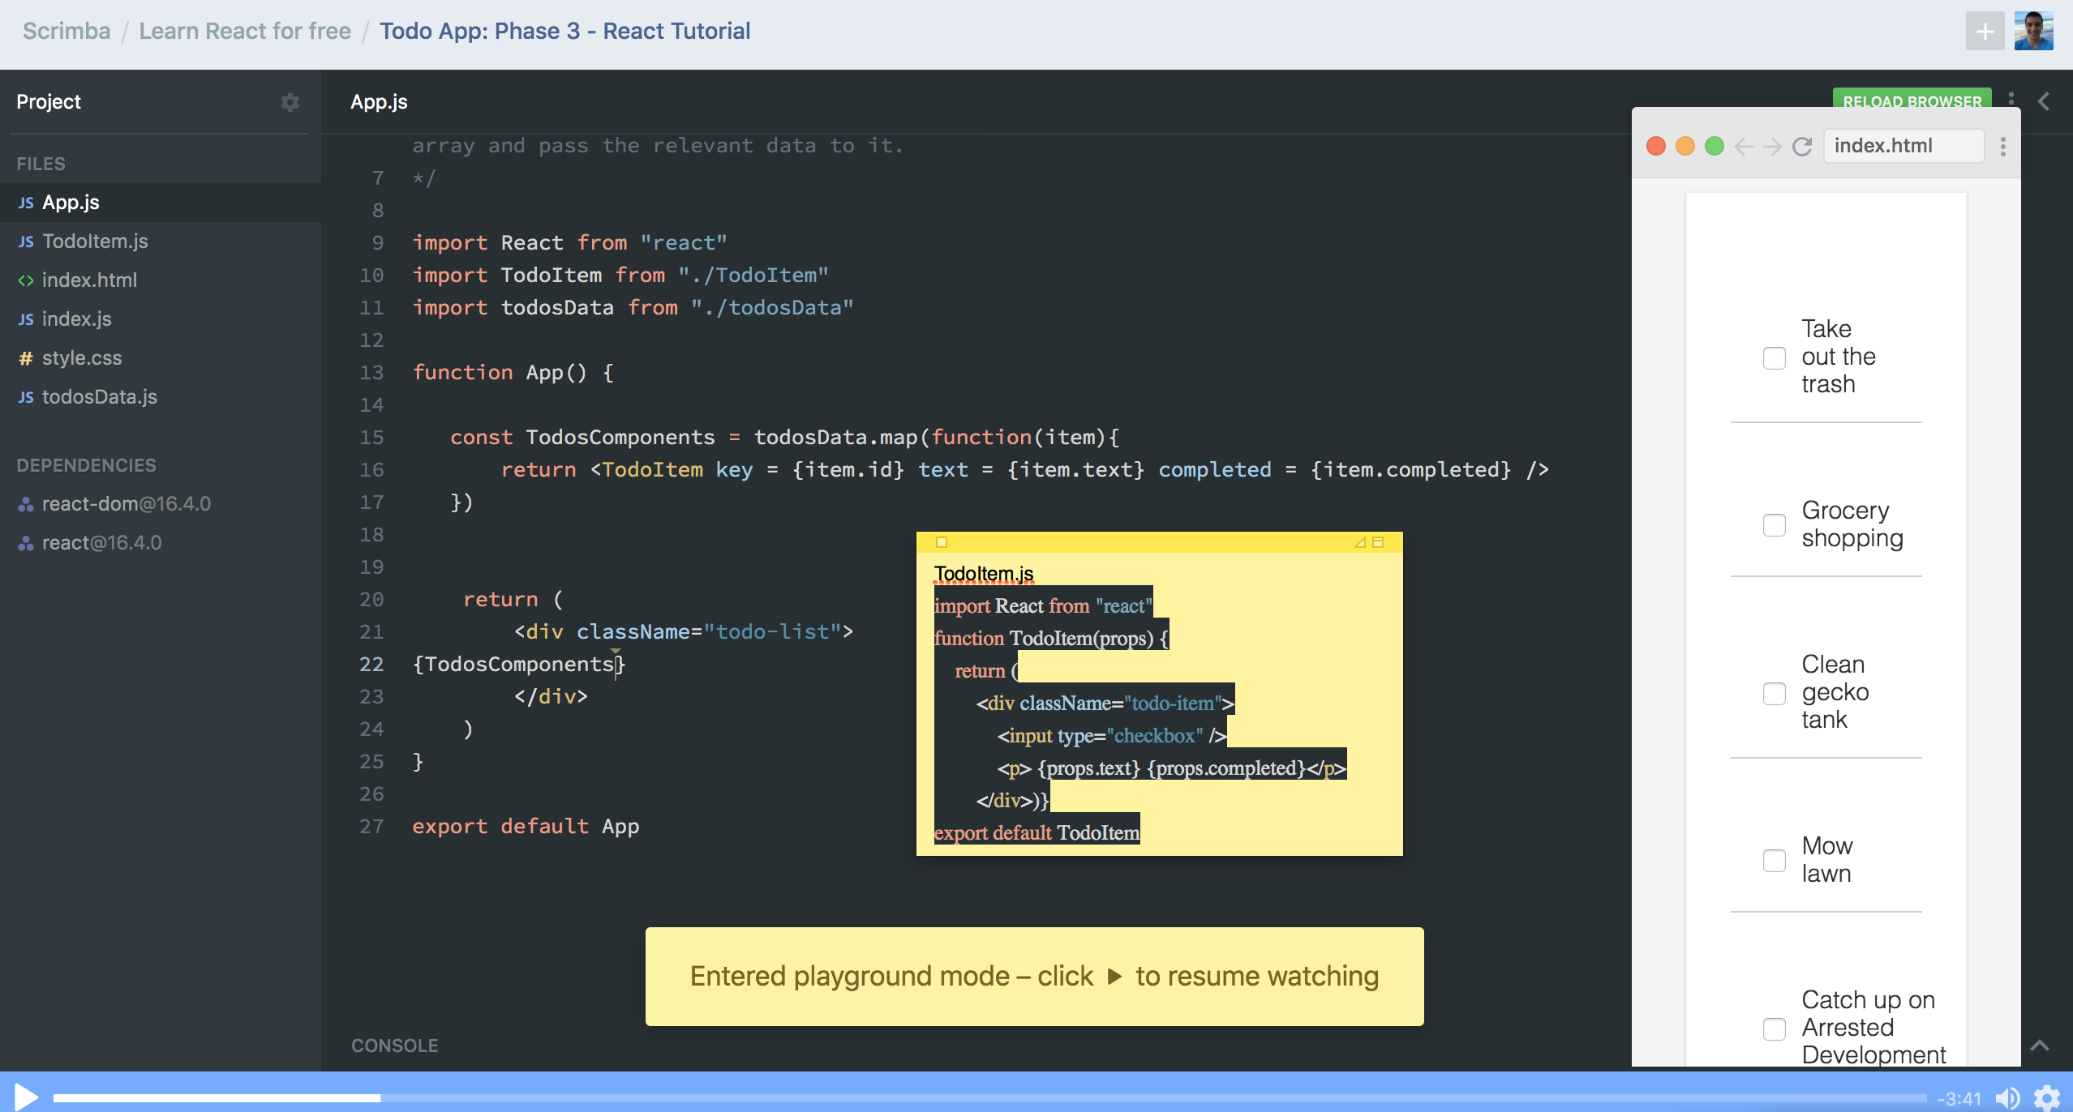

**Total time spent coding today: 1 hour 19 minutes**

**Total time spent coding thus far in May 2019: 12 hours 7 minutes**

**Total lifetime hours of coding: 508 hours 2 minutes**